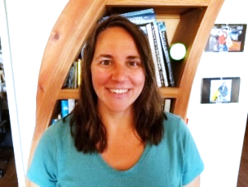

Sara Chudnoff, PG, Hydrogeologist, American Ground Water Trust, Pinetop, AZ

Sara recently joined the American Ground Water Trust. She has been working in the water resources and environmental field in New Mexico since the early 2000s. As a consulting scientist, she worked on projects from methane monitoring and reporting to hydrogeologic investigations and well design. In 2009, Sara left her regulatory role with the State and started working with Bernalillo County. In this position, she worked with hundreds of residents monitoring water levels and promoting outreach and education. At the New Mexico Bureau of Geology, she took this model to work on a State-Wide Groundwater Level Monitoring Network. Sara facilitates educational outreach for watershed health with the local school district and provides water resource consulting in New Mexico. She has a B.S. in Geology from New Mexico Tech and a M.S. in Water Resources from the University of New Mexico.